Project Three

App Launch Plan: Inventory App



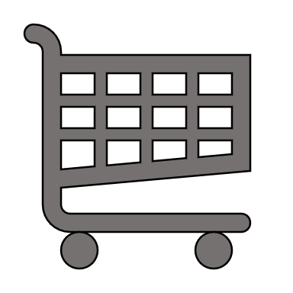

By: Mitchel Dauk

CS-360-10933

Mobile Architect & Programming

Southern New Hampshire University

The inventory app consists of a system that will allow a user to add and remove items, increase or decrease specific items, and notify the user when the inventory has reached zero. The database has a minimum of two tables with one storing the inventory items and one storing logins and passwords. There is a large grid that contains all the items in the inventory. Lastly, there is a login screen that will prompt the user to enter a username and password, as well as a way to create a new login account. This app will be used for companies that ship items, stores, and consumers.

In the app’s description, there will be a summary of what the app is and what the app can do. The description should include an easy-to-read explanation of how it will benefit the user, the key components, and future use. If the app has been tested with popular companies, I would also like to add what they think about it. There should be bullet points about what features the app has, such as “easy to add and delete items”, “ allows SMS notifications for items low on inventory”, “used by top corporate companies, such as…”, and “fully customizable with new updates coming later this month”. The app should also outline permissions and a privacy policy. The icon that best represents the app will be a semi-truck with a shopping cart and airplane inside. This shows that no matter how the item is shipped or delivered, it is crucial to get what you need.

The versions of Android that the inventory app should run on is Android 11: Red Velvet Cake and above. The reasoning behind this is security. While the app may seem simple right now, the app will eventually add more ways for users to input information. In reality, the inventory app shows an up-to-date of inventory for consumers and companies, which could be targeted by an outside source. Security is the most important piece and it was last updated this year, 2024.

My app will only ask for two permissions. One will be to track for errors and one will be to add SMS notifications for low inventory. Tracking for errors and allowing the creator to know when one happens will keep the app working with minimal downtime. If the team has to wait for someone to complain about it, it may be too late considering that there are many other inventory apps that may have less errors. SMS notification is a part of the feature that allows the user to know if there is low inventory. Although this can be turned off, the user should be asked for permission ahead of time. The app, at this point, does not need any other permissions because it is new and extremely basic. As time progresses, there may be an update to the permissions.

To make money, there will be two versions. One will have ads on the screen, and the other will be a paid app. At this time, a subscription is not needed because of how basic the app is. If the user does not want ads, there will be a one-time payment to enjoy the app without ads. In the future, there could be more add-ons such as companies, premade items, or even a way to scan the items and see their packaging details. This could force a subscription service that the user would have to pay for annually.

Resources

(http://web.ebscohost.com). (n.d.). https://web.ebscohost.com/